220Mhz Yagi antenna

Design parameters: .nec file
CM 8el 220Mhz antenna designed by PE1ITR (1985) method DL6WU.
CM Use fr VHF band 3 TV-DX.
CE Opt freq = 218Mhz
GW 0 7 0.0 -0.377 2.5 0.0 0.377 2.5 0.005
GW 2 7 0.255 -0.324 2.5 0.255 0.324 2.5 0.005
GW 3 7 0.363 -0.3075 2.5 0.363 0.3075 2.5 0.005
GW 4 7 0.608 -0.3055 2.5 0.608 0.3055 2.5 0.005
GW 5 7 0.903 -0.3035 2.5 0.903 0.3035 2.5 0.005
GW 6 7 1.247 -0.302 2.5 1.247 0.302 2.5 0.005
GW 7 7 1.63 -0.299 2.5 1.63 0.299 2.5 0.005
GW 8 7 2.042 -0.2955 2.5 2.042 0.2955 2.5 0.005
GE 0
EX 6 2 4 0 1.0 0.0
GN 2 0 0 0 5.0 .001
FR 0 1 0 0 217.0 0.0
EN

Horizontal far field pattern
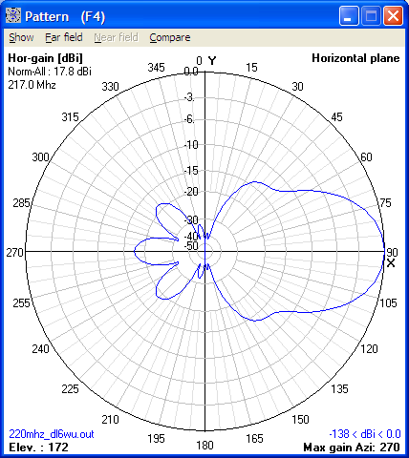

SWR
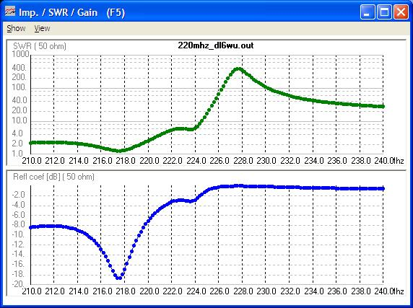

Geometry
